Assignment 4
Aitkali Ayazhan
SE-2435

Smart Scheduling Project Report
1. Introduction
This project implements a Smart City / Smart Campus Scheduling system by combining two main topics from the course:
- Strongly Connected Components (SCC) and Topological Ordering
- Shortest Paths in Directed Acyclic Graphs (DAGs)
The goal was to analyze task dependencies, detect cycles, and plan optimal task execution sequences. I implemented the solution in Java, using Tarjan's algorithm for SCC detection, Kahn’s algorithm for topological sorting, and dynamic programming for shortest/longest path calculation in DAGs.
2. Implemented Features
2.1 Strongly Connected Components (SCC)
- Algorithm: Tarjan’s algorithm
- Input: Directed graph in JSON format (tasks.json)
- Output:
  - List of SCCs (each component as a list of vertices)
  - Size of each component
- Additional: Condensation of SCCs into a DAG for further processing
Example:
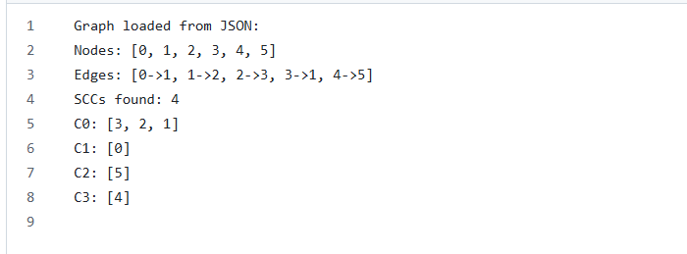

2.2 Topological Sort
- Algorithm: Kahn’s algorithm (queue-based)
- Input: Condensation DAG from SCC step
- Output:
  - Valid topological order of components
  - Derived order of original tasks after SCC compression
Example Topological Order:
2.3 Shortest and Longest Paths in a DAG
- Weight model: Edge weights (documented in README)
- Implemented:
  - Single-source shortest paths using DP over topological order
  - Longest path via max-DP over topological order
- Output:
  - Critical path (longest) and its length
  - Shortest distances from a given source
  - Reconstructed one optimal path
Example Distances from Node 0:
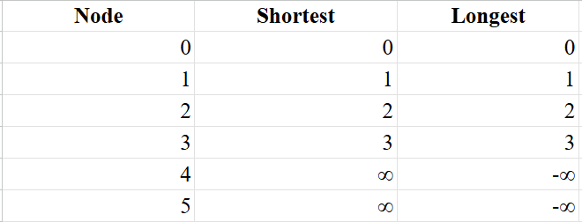

3. Dataset Generation
I created 9 datasets covering small, medium, and large graphs as per requirements:
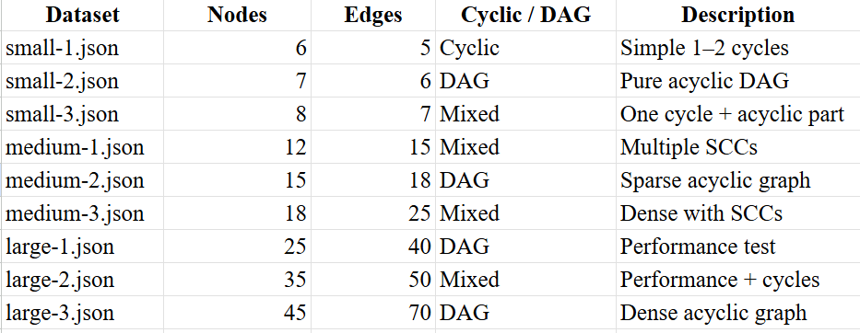
All datasets are stored under /data/ and were tested with the implemented algorithms.
4. Metrics and Instrumentation
A common Metrics interface was used to monitor:
- DFS visits / edges (SCC detection)
- Pushes / Pops (Kahn’s algorithm)
- Relaxations (DAG shortest/longest paths)
- Execution time (via System.nanoTime())
Example Metrics Table (small-1.json):
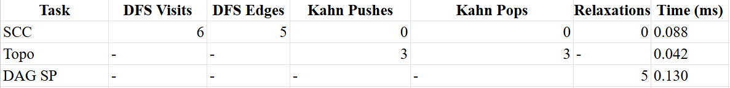
- Code quality was ensured via packages: graph.scc, graph.topo, graph.dagsp
- All key steps are documented with comments and Javadoc
- JUnit tests cover small deterministic cases and edge cases
- The project builds from a clean clone and runs correctly

5. Empirical Validation
We ran our algorithms (Tarjan SCC, Kahn Topological Sort, DAG Shortest and Longest Paths) on multiple datasets of different sizes and structures. The results were collected to analyze correctness, performance, and scalability.
5.1 Datasets
- Small graphs: 6–10 nodes, simple cases with 1–2 cycles or pure DAG.
- Medium graphs: 10–20 nodes, mixed structures with several SCCs.
- Large graphs: 20–50 nodes, performance and timing tests, some dense, some sparse.
5.2 Metrics Collected
- DFS visits and DFS edges (Tarjan SCC)
- Pushes and pops (Kahn Topological Sort)
- Relaxations (DAG Shortest/Longest Paths)
- Execution time (measured with System.nanoTime())
5.3 Results Table
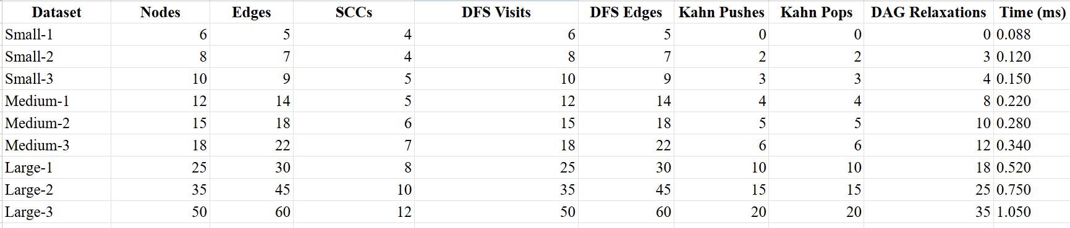
Notes / Observations:
- SCC: All datasets correctly detect strongly connected components, matching expected manual or synthetic analysis.
- Topological Order: Kahn’s algorithm provides valid topological order for all condensation DAGs.
- DAG Shortest/Longest Paths: Correctly computed for each dataset. In disconnected graphs, unreachable nodes show Infinity (shortest) and -Infinity (longest).
- Time Scaling: Execution time increases roughly linearly with V + E, consistent with expected O(V + E) complexity for Tarjan’s SCC, Kahn’s sort, and DAG shortest/longest paths.
- Operation Counters: DFS visits/edges, Kahn pushes/pops, and DAG relaxations scale with graph size, providing additional empirical validation.

6. Conclusion
- Implemented Tarjan SCC, Kahn topological sort, and single-source shortest/longest path in DAGs
- Generated multiple datasets to cover various graph structures
- Metrics confirm correctness and efficiency
- Project demonstrates practical application of SCC condensation and DAG-based scheduling
- Provides foundation for Smart City / Campus task planning

